Paleoclimatology Slide Sets
These resources are available online at: http://www.ncdc.noaa.gov/paleo/slides/slideset/

- The Ice Ages
- Climate and the Classic Maya Civilization
- Coral Paleoclimatology
- Coral Paleoclimatology for High School
- Polar Ice Cores
- Packrat Middens
- Tree Rings
- Heinrich Events
- Low Latitude Ice Cores

Paleo Slide Set: Tree Rings: Ancient Chronicles of Environmental Change

The Giant sequoia (Sequoiadendron giganteum) is the largest tree species on earth.
Tree rings record the fluctuation of environmental factors that influence tree growth during the life of the tree. In many cases, trees grow to be hundreds or even thousands of years old and thus are an important source of information about environmental change. Instrumental records of climate or other types of environmental variations exist for less than 100 years in most parts of the world. This length of record is not sufficient to answer questions such as: Is current global warming unusual, or is it part of the natural climate variability that we can expect over the long term? What is the range of precipitation variability that can be expected over centuries and millennia? With the climate information stored in tree rings, we can begin to answer such questions.  Photo Credits:  Peter Brown  Rocky Mountain Tree-Ring Research, Ft. Collins, CO | 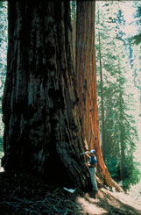  Click on above image to enlarge.  Download 1981 KB TIF Image

Paleo Slide Set: Tree Rings: Ancient Chronicles of Environmental Change

Extending a chronology based on living trees further back in time through crossdating.
Dendrochronology is the analysis of tree rings, including the dating of annual rings and study of patterns of ring characteristics, such as widths, density, and isotopic composition. In mid- to upper latitudes, or areas where there is seasonality in temperature and/or precipitation, many species of trees form annual growth rings. Because the same set of environmental factors influence tree growth throughout a region, the patterns of ring characteristics, such as ring widths, are often common from tree to tree. These patterns can be matched between trees in a process called crossdating, which is used to assign exact calendar year dates to each individual ring. Dated and measured rings from a number of trees in a region are combined to form a tree-ring chronology. The chronology provides two main types of information:  - The chronology can be used as a tool for dating events that caused tree death or a marked change in the appearance of a ring or set of rings. The death date can be used to date the tree cutting involved in the construction of wooden dwellings. Scars can record the timing of events such as fire, flood, avalanche, or other geomorphological events, while sequences of suppressed or larger rings record events such as insect infestation, effects of pollution, or changes in forest dynamics.  - The chronology is an average of coherent variations in growth from a number of trees. It enhances the common pattern of variation or "signal" -- usually related to climate -- while the non-common variance, or "noise" is dampened. Chronologies from trees that are sensitive to climate can be used to reconstruct past variations in seasonal temperature, precipitation, drought, streamflow, and other climate-related variables.  Photo Credits:  Laboratory of Tree-Ring Research, The University of Arizona | 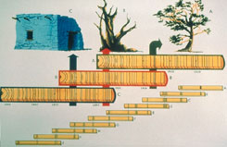  Click on above image to enlarge.  Download 1957 KB TIF Image

Paleo Slide Set: Tree Rings: Ancient Chronicles of Environmental Change

Keet Seel Ruins, Navajo National Monument, Arizona
The father of dendrochronology is widely acknowledged to be A.E. Douglass, who came to Arizona at the turn of the 20th century as an astronomer interested in sunspots and climate. A pioneer in the study of the relationships between tree growth, climate, and solar cycles, he was also instrumental in developing dendrochronology as a method to date archaeological remains. By matching the ring patterns in wood from roof beams and around door and window openings with the patterns in a dated tree-ring chronology derived from living trees, he and others were able to date many of the Anasazi ruins in the southwestern United States. The Anasazi ruin Keet Seel was built around AD 1250. The Anasazi are believed to be the ancestors of the modern Pueblo Indians of northern Arizona and New Mexico. They inhabited parts of Colorado, Utah, Arizona, and New Mexico from about AD 900-1300. During this time, they built many cliff dwellings and multi-storied towns in the canyon country of the southwestern U.S., of which Keet Seel is one example.  Photo Credits:  Peter Brown  Rocky Mountain Tree-Ring Research, Ft. Collins, CO | 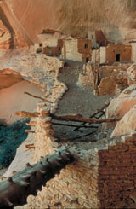  Click on above image to enlarge.  Download 1967 KB TIF Image

Paleo Slide Set: Tree Rings: Ancient Chronicles of Environmental Change

Diagram of rings in a young conifer from Fritts, 1976.
How does a tree produce annual rings? This slide shows part of a cross section of a young conifer. The center of the tree is the pith and the outside of the tree is marked by the bark. Just inside the bark is the vascular cambium, where cells that form rings are produced. Each year, the cambium produces phloem and xylem cells. Phloem cells are formed on the outside of the cambial layer, and transport sugars and other photosynthetic products throughout the tree. Xylem cells are formed inside the cambial layer, and their function is to transport water from the roots up through the trunk of the tree. The cells of the phloem layers are compressed over time and become part of the bark. The xylem cells remain rigid wood, and are the building blocks of tree rings.  There are two main types of ring producing trees, gymnosperms (non-flowering seed plants such as conifers) and angiosperms (flowering plants including trees such as oaks, beech, and aspen). The primary cellular component of tree rings in gymnosperms is the tracheid. Tracheids are long tubular cells that make up the xylem. Tracheids formed in the beginning of the growing season are thin walled and low in density. These cells constitute what is called the earlywood. As the end of the growing season nears, climate conditions become less conducive and growth slows. Tracheids become darker and more thick-walled, forming the latewood. Finally, when the growth season ends, there is a marked boundary at the edge of the ring. The changes in the tracheid characteristics can be seen in the rings of the conifer shown in the slide. The earlywood portion of the ring appears lighter in color to the naked eye, and the latewood appears dark, forming the visible light and dark bands within the annual rings.  Photo Credits:  NOAA Paleoclimatology Program | 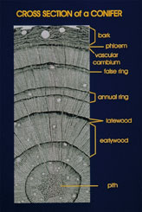  Click on above image to enlarge.  Download 2014 KB TIF Image

Paleo Slide Set: Tree Rings: Ancient Chronicles of Environmental Change

Green ash (Fraxinus pennsylvanica) ring structure, including clearly visible vessels.
The main element in the rings of angiosperms is the vessel. Vessels are similar in function to tracheids in gymnosperms. Annual rings can be discerned in angiosperms through the decrease in vessel size in ring-porous species (such as oak) or through the change in fiber characteristics in diffuse-porous species (such as beech).  Photo Credits:  Rex Adams  Laboratory of Tree-Ring Research, The University of Arizona,Tucson, AZ | 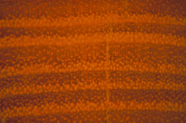  Click on above image to enlarge.  Download 1988 KB TIF Image

Paleo Slide Set: Tree Rings: Ancient Chronicles of Environmental Change

False rings in Mexican cypress (Cupressus lusitanica).
Under certain climatic conditions, some species will form intra-annual or false rings . If climatic conditions are unfavorable to growth during the growing season, the tree may mistakenly sense that the end of the season is near, and produce dark, thick-walled latewood cells. Improved conditions will cause the tree to produce lighter, thinner-walled cells once again, until the true end of the season. The resulting annual ring looks like two rings, but when this first ring is closely inspected it can be identified as false because the latewood boundary grades back into the earlywood. False rings occur in a number of species such as the Mexican cypress pictured here. Young ponderosa pines in southeastern Arizona commonly contain false rings as well. In this region, winter and early spring rains provide moisture to trees in the early part of the growing season. By May and June, the driest part of the year, trees have used up the available moisture and, if stressed enough, will begin to produce latewood cells. However, monsoon moisture usually begins to fall in July, and with this moisture, trees will again produce earlywood cells.  Photo Credits:  Peter Brown  Rocky Mountain Tree-Ring Research, Ft. Collins, CO | 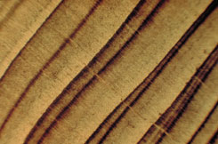  Click on above image to enlarge.  Download 1997 KB TIF Image

Paleo Slide Set: Tree Rings: Ancient Chronicles of Environmental Change

Locally absent ring in Scots pine (Pinus sylvestris).
Under other climate conditions, trees may produce only a partial ring or may fail to produce a ring at all. This may occur in a year in which conditions for growth are particularly harsh. These rings are called locally absent or missing rings and are commonly found in trees which are extremely sensitive to climate. A partial ring is visible in the upper portion of this slide. This ring gets pinched between the rings to the left and right of it and is not visible at all in the lower portion of the slide. Very old and/or stressed trees may also produce very small, barely visible rings only a few cells wide which are called micro-rings. Because of the occurrence of false, locally absent, micro, and missing rings, it is especially important to prepare surfaces carefully and use the technique of crossdating to ensure exact calendar year dates for individual rings. More about this later!  Photo Credits:  Jonathan Pilcher  Palaeoecology Centre, Queen's University, Belfast | 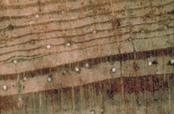  Click on above image to enlarge.  Download 1960 KB TIF Image

Paleo Slide Set: Tree Rings: Ancient Chronicles of Environmental Change

Coring huon pine (Lagarostrobus franklinii) in Tasmania.
The work of a dendrochronologist starts with the collection of samples in the field. The particular problem being addressed will dictate site and tree selection so that trees sampled are sensitive to the environmental variable of interest. Once at the site, there are two ways to obtain tree-ring samples. Most commonly, tree-ring samples are collected using a hand-held increment borer to remove a small core of wood roughly 5mm in diameter from the trunk of the tree, ideally from bark to pith. An increment borer is a hollow shaft of steel with a sharp threaded bit at the tip. A handle fits into the opposite end and is used to turn the borer into the tree. Once the borer has been inserted into the tree, a metal extractor or "spoon" is used to remove the core from the shaft. The borer is then removed from the tree. Most trees are very effective at compartmentalizing and closing the small bore hole, just as the tree would close a natural wound caused by insects, weather, etc. Thus, coring does not cause any serious damage to most tree species. Usually, two cores are taken from each tree to facilitate crossdating and to reduce the effects of ring-width variations related to differences in the two sides of the tree. The number of trees sampled from the site depends on how sensitive the trees are to the environment, but the average is about 20-30 trees. In this slide, an increment borer has been inserted into the trunk of the tree and the scientist is holding the extractor with the core on it.  Photo Credits:  Edward Cook  Lamont-Doherty Earth Observatory, Columbia University, Palisades, NY: slides | 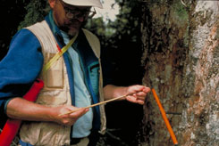  Click on above image to enlarge.  Download 2014 KB TIF Image

Paleo Slide Set: Tree Rings: Ancient Chronicles of Environmental Change

Cutting cross-section from subfossil huon pine (Lagarostrobus franklinii) log, Tasmania.
Sometimes it is more useful to have a full cross section of the tree for analysis, but scientists do not want to destroy living trees and so take full cross sections only from dead trees, logs, or stumps. This "remnant" material can remain intact on the ground or buried for hundreds to thousands of years under certain conditions (cold and/or dry, under water, or in peat bogs), and can provide very valuable information about variations in climate beyond the span of living trees. If these samples overlap in time with living trees, they can be crossdated and incorporated into a live tree-ring chronology. A European oak chronology has been developed from subfossil oak buried in peat bogs and river gravel that spans over 7 millennia (Baillie, 1995). This photo shows a sample being cut from a subfossil huon pine that died around AD 1200. The sample was later used to help extend the huon pine chronology back to 200 BC.  Photo Credits:  Edward Cook  Lamont-Doherty Earth Observatory, Columbia University, Palisades, NY: slides | 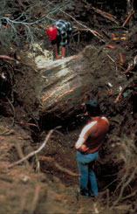  Click on above image to enlarge.  Download 1931 KB TIF Image

Paleo Slide Set: Tree Rings: Ancient Chronicles of Environmental Change

Mounted huon pine (Lagarostrobus franklinii) core samples.
After the fieldwork is completed, the cores or cross section samples are returned to the laboratory where they are prepared for dating and measuring. Cores are first dried and then glued into wooden core mounts. Cross sections are sometimes in pieces and may need to be glued together or mounted on a sheet of wood to prevent breakage. Cores and cross sections are then sanded using progressively finer grits of sandpaper, or trimmed with razor blades, to produce a smooth surface so that the finest details of the rings are visible under the microscope. The cores shown in this slide are marked with series of dots. The set of three dots represent a century (in this case, 1900), and the single dots represent the first year in a decade.  Photo Credits:  Edward Cook  Lamont-Doherty Earth Observatory, Columbia University, Palisades, NY: slides | 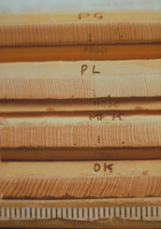  Click on above image to enlarge.  Download 2106 KB TIF Image

Paleo Slide Set: Tree Rings: Ancient Chronicles of Environmental Change

Skeleton plots
As stated before, dendrochronological dating is not based on simple ring counting, but instead relies on matching patterns of ring widths from tree to tree. The ring-width patterns are plotted on skeleton plots, which are representations of the patterns of frequency and magnitude of the narrowest rings, as well as other notable ring characteristics. Skeleton plot are used to develop a pattern of characteristic rings for each sample that can be matched from tree to tree. The pattern matching allows for the detection of missing and false rings and other dating errors and is used to ensure accurate dating. In the skeleton plots shown in this slide, the little black flags at the ends of each plot indicate the first and last rings in the sample. The length of the plotted lines correspond inversely to the narrowness of the surrounding rings, and thus, the longest lines match with the narrowest rings.  Photo Credits:  Connie Woodhouse  NOAA Paleoclimatology Program | 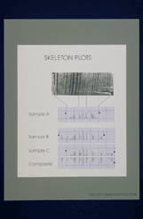  Click on above image to enlarge.  Download 1977 KB TIF Image

Paleo Slide Set: Tree Rings: Ancient Chronicles of Environmental Change

Measuring a tree-ring core on a moveable-stage microscope.
Once all rings are accurately crossdated, the ring widths in each sample are measured under a microscope on a sliding stage micrometer accurate to the nearest 0.01mm, and recorded in computerized data files. Other techniques are used to measure ring density and isotopic composition. This slide shows a microscope and measuring machine connected to a computer. Ring boundaries can be viewed through the microscope. A core on the stage of the machine is measured using a hand crank (near end of the stage) to move the stage with the core one ring width at a time. Once the measurement is made, an encoder converts the movement of the platform into a distance signal. The signal is converted into a width measurement, and recorded in a file in the computer.  Photo Credits:  Elaine Kennedy Sutherland  U.S.D.A. Forest Service, Delaware, OH | 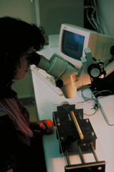  Click on above image to enlarge.  Download 1995 KB TIF Image

Paleo Slide Set: Tree Rings: Ancient Chronicles of Environmental Change

Plot of several individual ring-widths series illustrating the need for standardization.
The raw ring-width measurements from each core collected at one ecologically homogeneous sampling site are combined into a site chronology, which reflects the common tree growth variations at the site over time. However, the ring measurement series for each core must first be standardized before they can be combined into a site chronology. Standardization is necessary for several reasons. First, individual trees grow at different rates, and so faster growing individuals with higher absolute ring widths would dominate a simple average of ring widths. Second, most individuals put on smaller rings later in life, and thus a simple average of growth rings would tend to retain the long-term ring-width decline due to increasing trunk circumference of the trees, instead of reflecting a desired signal such as climatic variations. Finally, the standardization process is used to remove variations in growth due to factors unrelated to the desired signal. For example, low frequency variations in growth due to disturbances such as fire or insect infestations can be removed when assessing climatic variations.  The standardization process involves fitting a smooth curve to the ring-width series and then dividing each ring width value by the corresponding curve value to produce a series of ring-width indices with a stationary mean. This process allows samples with large differences in growth rates to be combined, and can be used to remove any undesired growth trends present. For example, a typical sample might display exponentially declining growth with age, the classic biological growth curve. Standardizing this sample using a negative exponential function results in data values that represent the departure from the expected biological growth trend for each year. Indices from numerous trees can then be combined into a site chronology. The chronology is a time series of indices that represent the departure of growth for a given year from the series mean. Higher or lower values for a given year represent proportionally higher or lower tree growth for that year.  Photo Credits:  Graphic by Connie Woodhouse, based on Fritts 1976 fig. 1.9  NOAA Paleoclimatology Program | 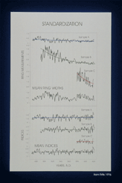  Click on above image to enlarge.  Download 2022 KB TIF Image

Paleo Slide Set: Tree Rings: Ancient Chronicles of Environmental Change

Foxtail pines (Pinus balfouriana) at upper treeline, Sierra Nevada Mountains, California.
A sub-field of dendrochronology, dendroclimatology, is the study of the relationships between climate and tree-ring characteristics, and the reconstruction of climate records from these relationships. The growth of trees, as well as other organisms, proceeds only as fast as allowed by the most limiting environmental factor. The year-to-year variations in this factor are reflected in the variations in annual ring characteristics. To obtain climate information, trees that are sensitive to climate must be located and sampled. Sites that are good candidates for dendroclimatic studies are those in which trees are strongly influenced and stressed by climate, while not greatly affected by non-climatic factors such as competition from other trees, fire, or human activities. Different species of trees have different ecological ranges in which they will grow. Frequently, trees that are the most sensitive to climate will be found at the margins of their ecological ranges or at environmentally stressed sites within their range. In this figure, foxtail pines near alpine treeline are at the upper elevational limits of their range, and their growth is strongly influenced by the harsh climate.  Photo Credits:  Anthony Caprio  Sequoia and Kings Canyon National Parks, CA | 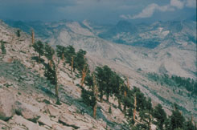  Click on above image to enlarge.  Download 1994 KB TIF Image

Paleo Slide Set: Tree Rings: Ancient Chronicles of Environmental Change

Baldcypress (Taxodium distichum) in Bayou DeView, Arkansas.
Information about a particular climate variable can be maximized through careful site selection. For example, if one is interested in how rainfall has varied over time, a steep, rocky, dry, south-facing slope in an arid environment may be selected to find trees under maximum water stress. In such cases, ring width is a strong proxy for precipitation. In the previous slide, the foxtail pines in the cold environment near upper treeline are sensitive to summer temperatures and growing season length. They will likely reflect these variables in their ring-width patterns. In this slide, the baldcypress growing in a swamp is, surprisingly, a good recorder of spring rainfall in the southeastern United States. High rainfall is related to high dissolved-oxygen levels, which promote baldcypress growth. The baldcypress root system, responsible for uptake of water and nutrients, also appears to be very sensitive to water level.  Photo Credits:  Dave Stahle  Department of Geography, University of Arkansas, Fayetteville, AR | 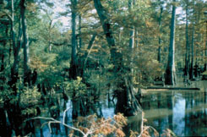  Click on above image to enlarge.  Download 1995 KB TIF Image

Paleo Slide Set: Tree Rings: Ancient Chronicles of Environmental Change

Bristlecone pine (Pinus longaeva), White Mountains, California.
Since one of the goals of dendroclimatology is to reconstruct climate for as long of a period as possible, the oldest trees that can be found are sampled. Old trees are not always the biggest trees, but are commonly characterized by heavy, gnarled limbs, spiked tops, and in the case of ancient bristlecone pine, "strip bark" stems with only a narrow ribbon of living bark (cambium). Bristlecone pine of the Great Basin region of western North America are the oldest known living trees, up to 5,000 years old.  Photo Credits:  Jonathan Pilcher  Palaeoecology Centre, Queen's University, Belfast | 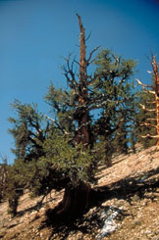  Click on above image to enlarge.  Download 1993 KB TIF Image

Paleo Slide Set: Tree Rings: Ancient Chronicles of Environmental Change

Observed & reconstructed number of precipitation days in winter, northern Arizona & New Mexico.
A tree-ring chronology built from old, sensitive trees will reveal the common climate signal found in the trees throughout an area. The chronology, usually in the form of a time series of ring width or density indices, is calibrated with a climate record for the period of time common to both climate records and the chronology. The character of the relationship between climate and tree growth is assessed and a statistical model is derived to describe that relationship. In this figure, the total number of precipitation days in winter for a region in northern Arizona and New Mexico was reconstructed from a set of tree-ring chronologies in the southwestern United States. The purple line shows the observed record of numbers of precipitation days while the green line shows the values reconstructed from the chronologies. The match, although not perfect, is very close, and reflects both high and low frequency variations in precipitation days in this region for centuries prior to the availability of instrumental observation.  Photo Credits:  Connie Woodhouse  NOAA Paleoclimatology Program | 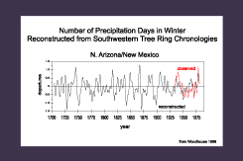  Click on above image to enlarge.  Download 1935 KB TIF Image

Paleo Slide Set: Tree Rings: Ancient Chronicles of Environmental Change

Reconstructed Palmer Drought Severity Index for 1863, from Cook et al, 1997
Climate reconstructed from tree rings can show both spatial and temporal variations in climate. Cook et al. (1997) reconstructed periods of drought for a set of grid points across the United States, from 1700 to the present. For each year, the distribution of drought severity was mapped, using the Palmer Drought Severity Index (PDSI). This slide shows areas of drought in the year 1863, a very dry year for the northern Great Plains. The extremely dry areas are shown in red, areas of average rainfall in white, and areas with very wet conditions are blue.  Photo Credits:  Ed Gille  NOAA Paleoclimatology Program | 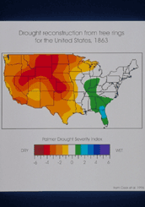  Click on above image to enlarge.  Download 2115 KB TIF Image

Paleo Slide Set: Tree Rings: Ancient Chronicles of Environmental Change

Precipitation reconstruction for western New Mexico from Grissino-Mayer, 1996.
Variations in precipitation for the last 2,000 years can been seen in the tree-ring reconstruction of annual rainfall for western New Mexico. This reconstruction, from ponderosa pine and Douglas fir, dates back to AD 136 and shows how extremes in precipitation in the 20th century compare to those of the past. The graph in this figure shows the well-known drought of the 1950s, but it also shows droughts of much greater magnitude and length in the late 1500s, around 750, and between 425 and 500.  Photo Credits:  Graphic modified from Grissino-Mayer, 1996, by Connie Woodhouse  NOAA Paleoclimatology Program | 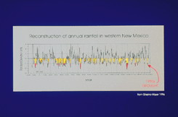  Click on above image to enlarge.  Download 1991 KB TIF Image

Paleo Slide Set: Tree Rings: Ancient Chronicles of Environmental Change

World map of tree-ring sites, International Tree-Ring Data Bank
Dendrochronology and its role in global change studies.  As the impact of human activities on the environment becomes more marked, there is increased concern about the scale and implications of the changes caused by these activities. Climatic changes that occur as a result of anthropogenic activities will be superimposed upon the natural climatic variability. A key to detection and/or prediction of future global changes lies in understanding the causes and characteristics of variability in the past.  Dendrochronology contributes to the study of global change in many ways. Tree-ring research has produced long-term reconstructions of climate which can be used to:  - Evaluate current variability and trends in climate in the context of past years.  - Identify periods of time or locations of anomalous climate change in the past that may provide clues about the potential behavior of climate and areas that may be particularly sensitive to climate change in the future.  - Study the climatic impact of volcanic eruptions, solar cycles, or El Niño events prior to the advent of instrumental records.  Tree-ring chronologies can provide excellent, exactly dated estimates of climate variability for hundreds or even thousands of years during the Holocene, and therefore are vital for the study of global change.  This map shows the locations of many of the tree-ring chronologies that exist today. Note that most are located in the Northern Hemisphere, specifically in North America and Europe, and that few chronologies have been developed for much of Asia. The temperate forests of the Southern Hemisphere also contain trees suitable for dendrochronology, although few chronologies currently exist for these areas. Recent research has indicated that a few select tree species growing in tropical areas that experience wet and dry seasons may also contain annual rings and be useful for dendrochronological studies.  Photo Credits:  Wendy Gross and Connie Woodhouse  NOAA Paleoclimatology Program | 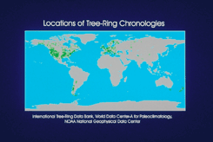  Click on above image to enlarge.  Download 2023 KB TIF Image

